**Assignment 7 joins**

Q1. Write a query to display all the orders from the orders table issued by the salesman &#39;Paul Adam&#39;.

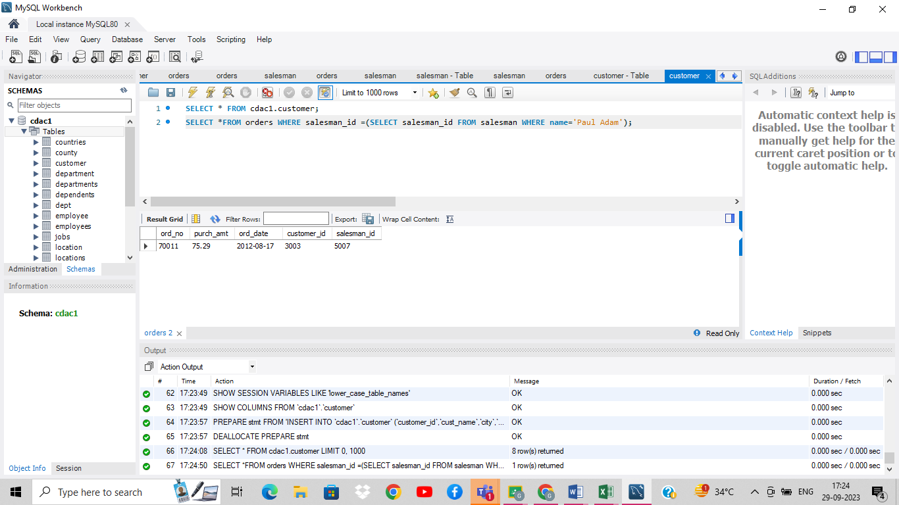

Q2. Write a query to display all the orders for the salesman who belongs to the city New York.

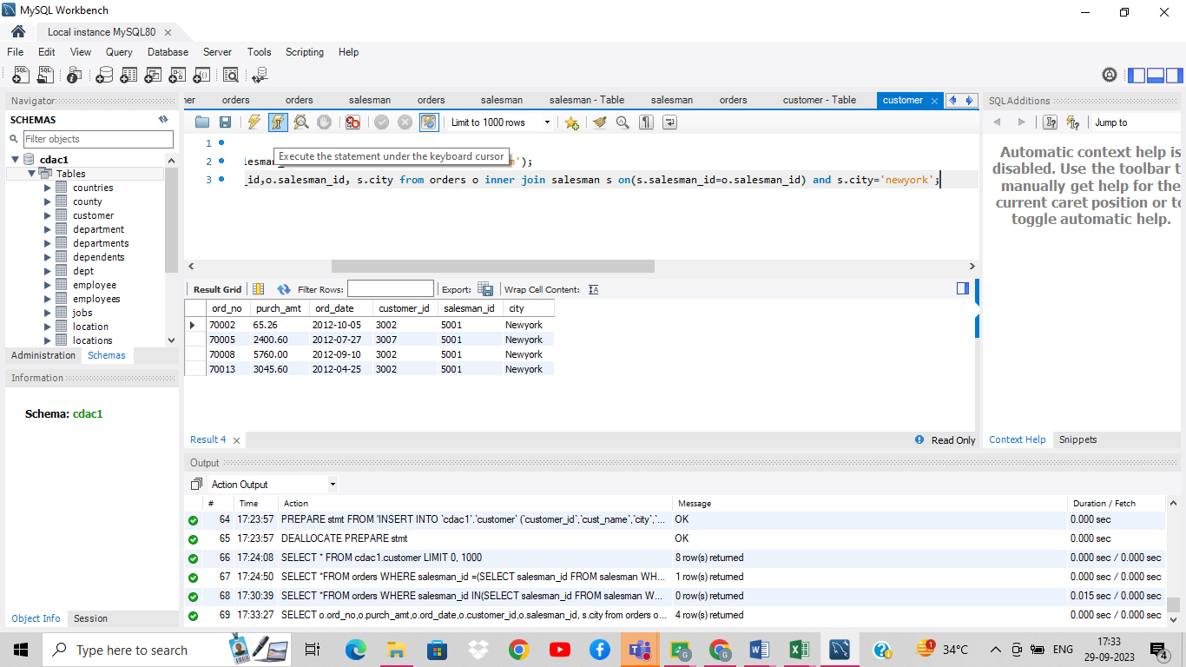

Q3. Write a query to find all the orders issued against the salesman who works for customer whose id is

3007.

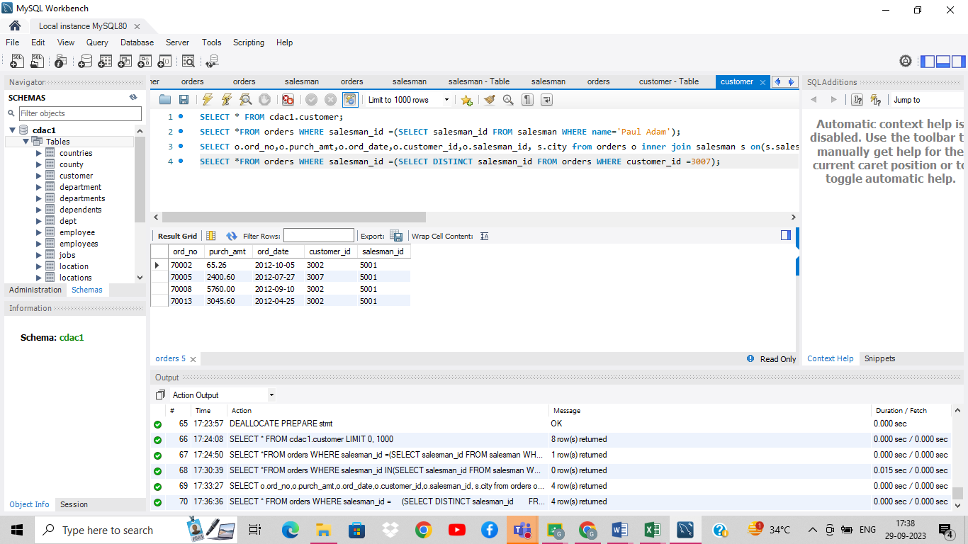

4. Write a query to display all the orders which values are greater than the average order value for

10th October 2012.

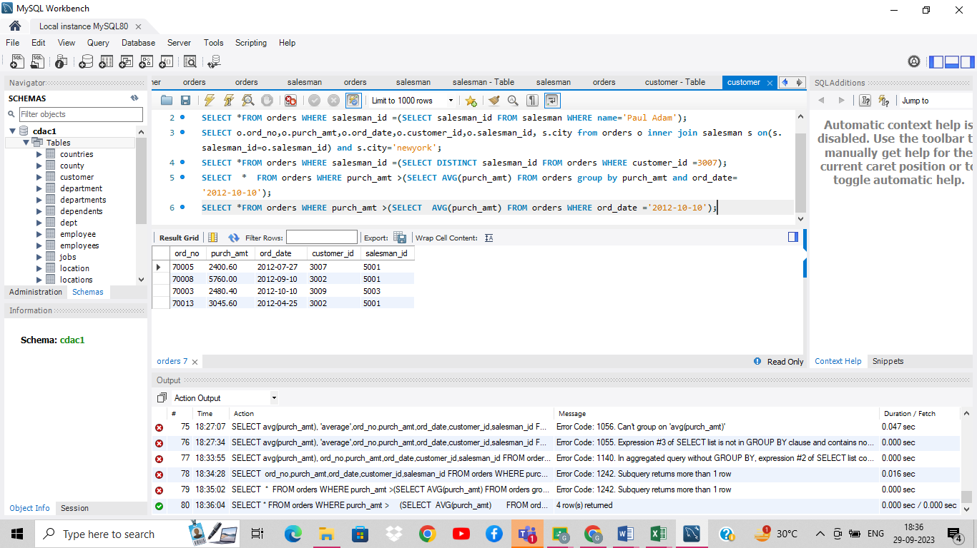

Q5. Write a query to find all orders attributed to salesman in New york.

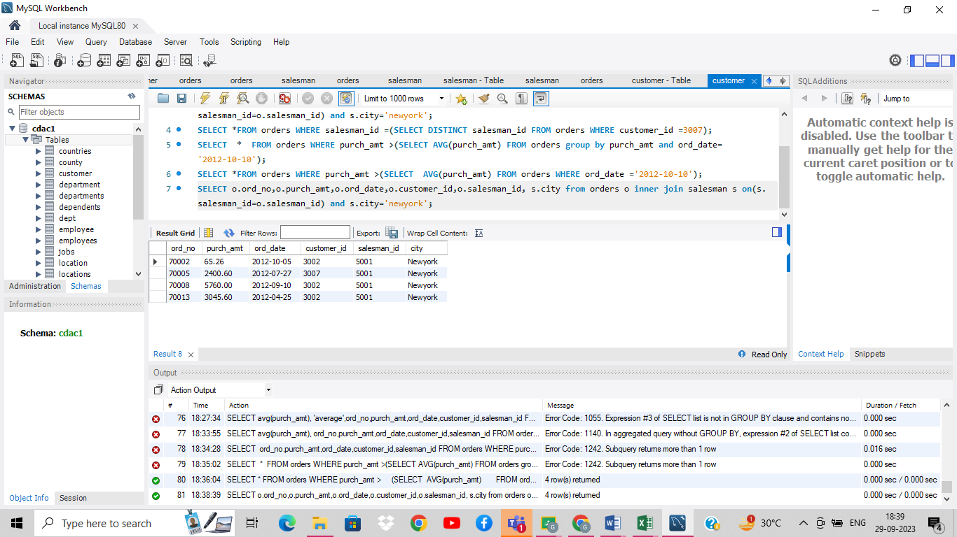

6. Write a query to display the commission of all the salesmen servicing customers in Paris.

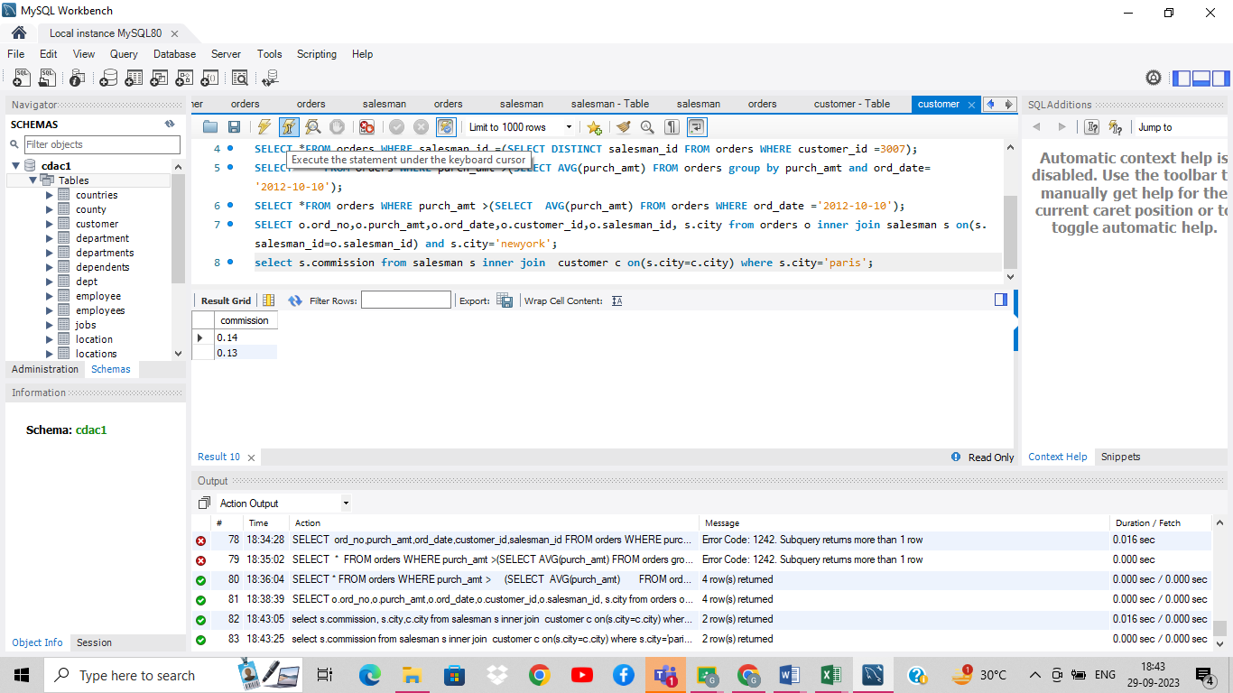

Q7. Write a query to display all the customers whose id is 2001 bellow the salesman ID of Mc Lyon.

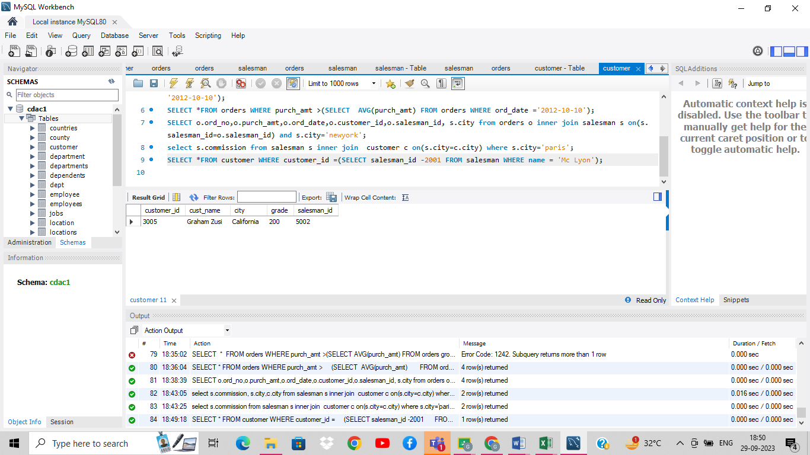

Q8. Write a query to counts the customers with grades above New York average.

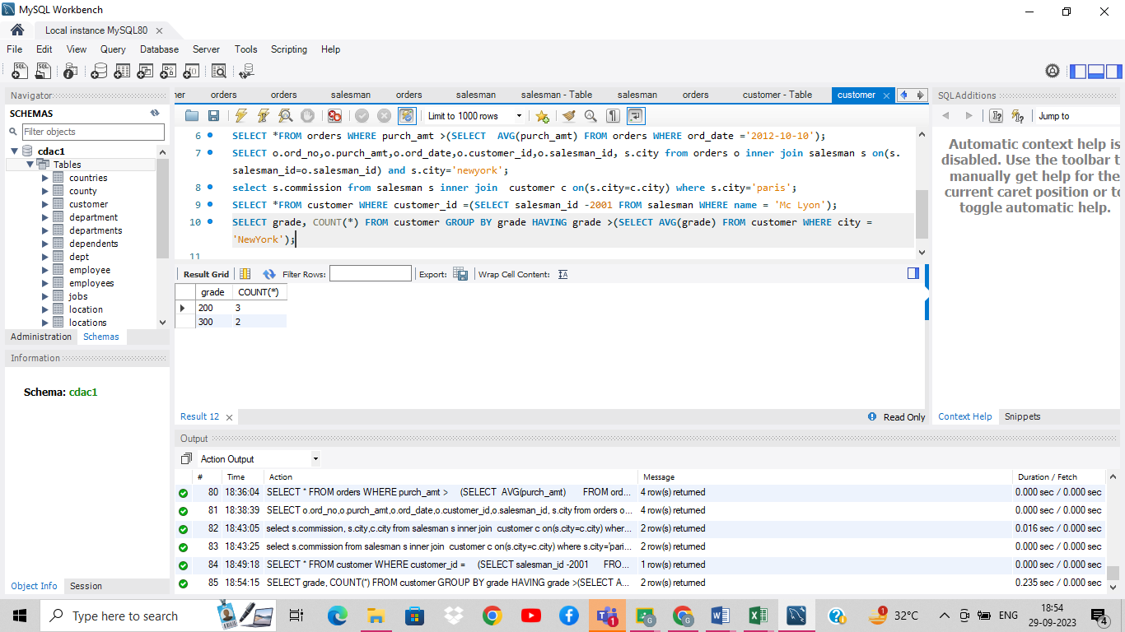

Q9. Write a query to display all customers with orders on October 5, 2012.

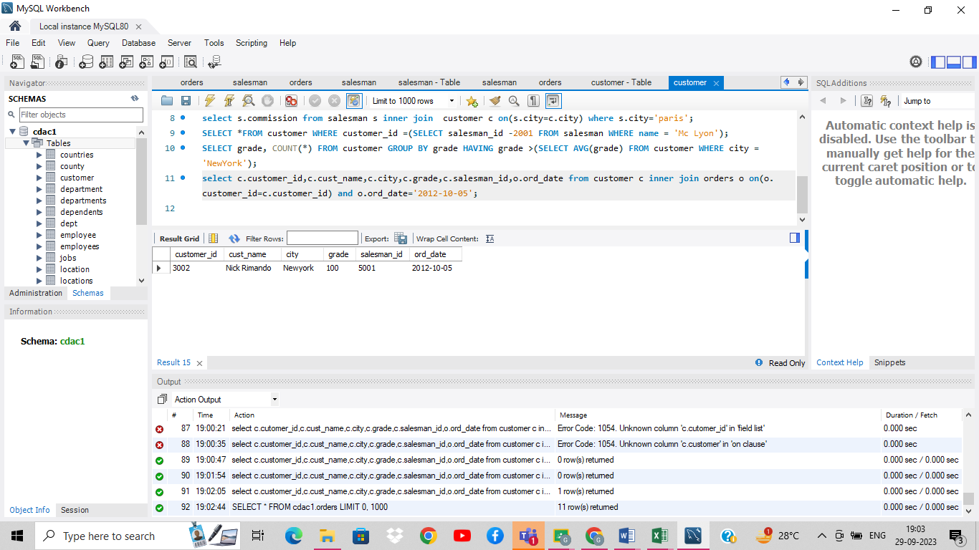

Q10. Write a query to display all the customers with orders issued on date 17th August, 2012.

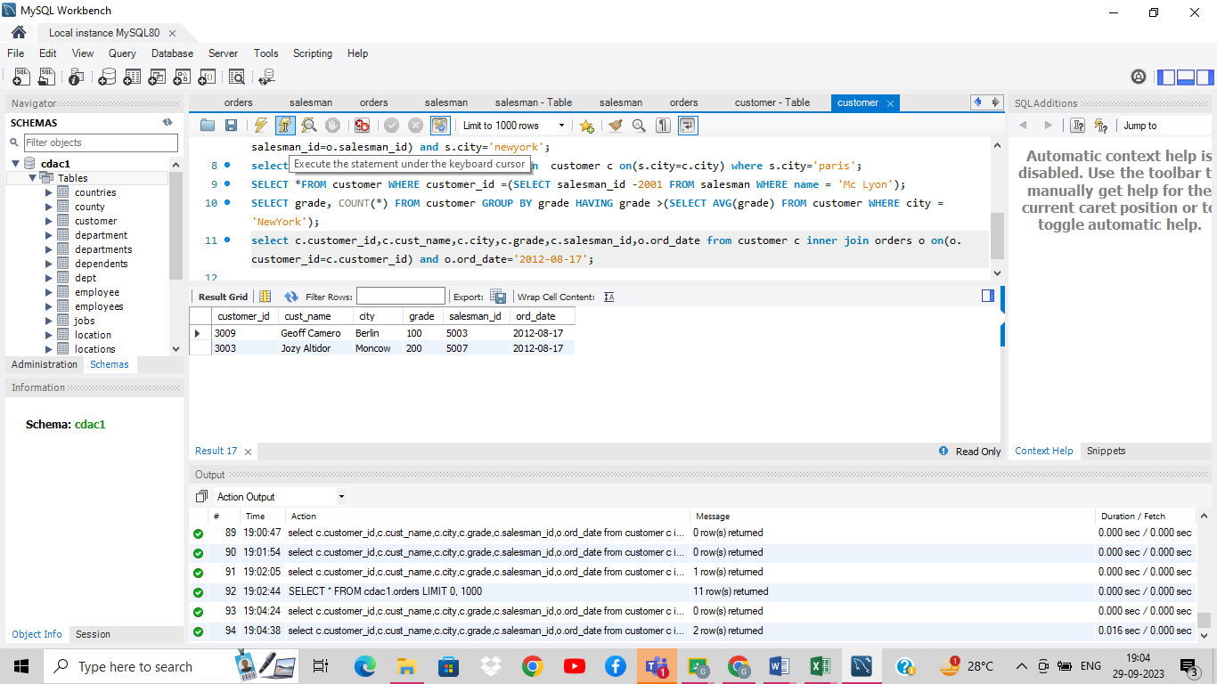

Q11. Write a query to find the name and numbers of all salesmene who had more than one customer.

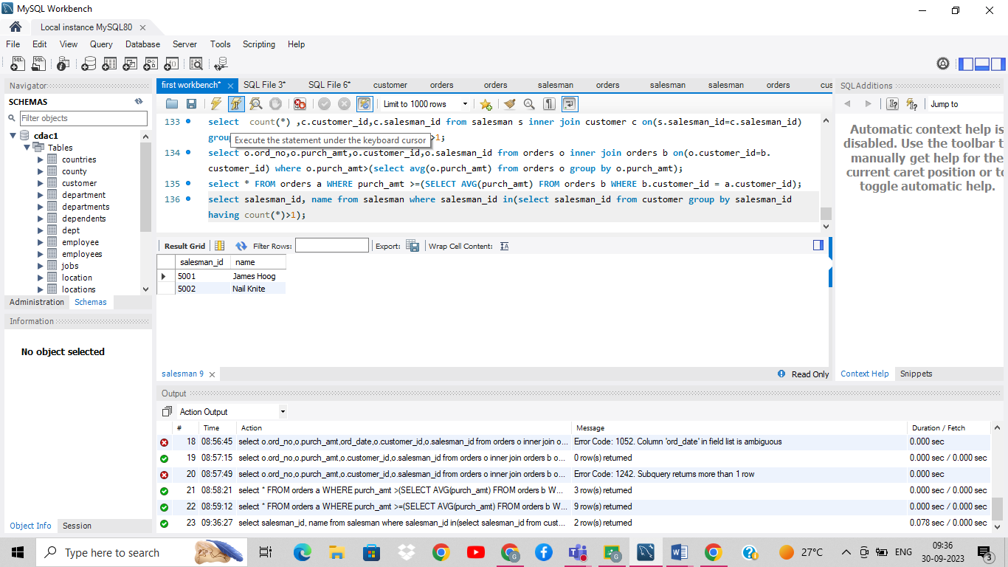

Q12. Write a queries to find all orders with order amounts which is above-average amounts for their

customers.

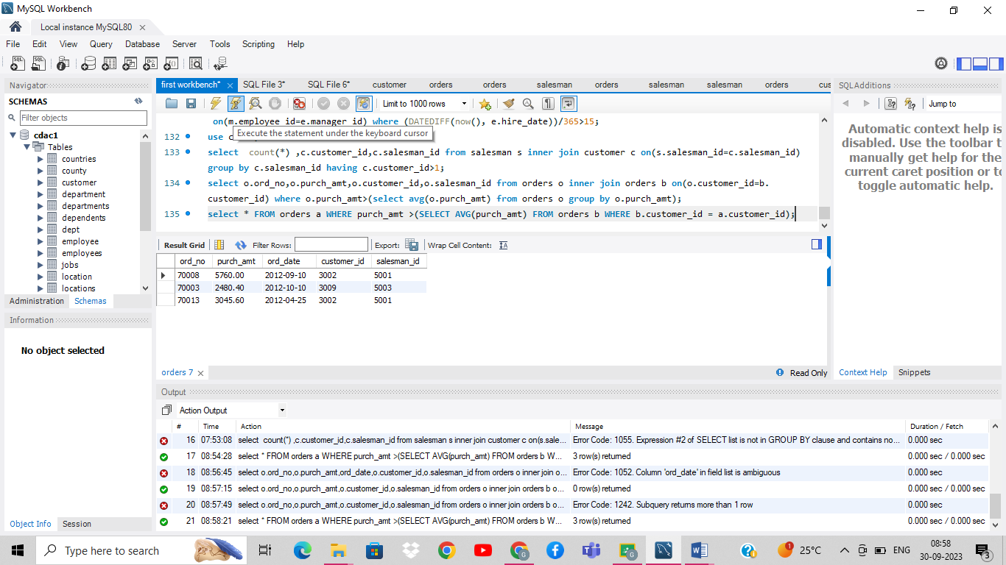

Q13. Write a queries to find all orders with order amounts which is on or above-average amounts for

their customers.

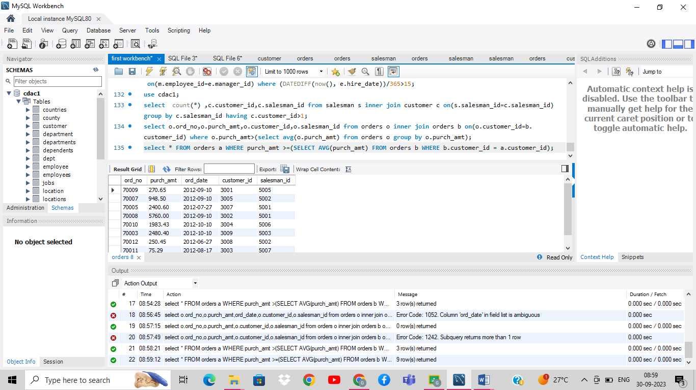

Q14. Write a query to find the sums of the amounts from the orders table, grouped by date, eliminating

all those dates where the sum was not at least 1000.00 above the maximum order amount for that date.

Q15. Write a query to extract the data from the customer table if and only if one or more of the

customers in the customer table are located in London.

Q16. Write a query to find the salesmen who have multiple customers.

Q17. Write a query to find all the salesmen who worked for only one customer.

Q18. Write a query that are extracts the rows of all salesmen who have customers with more than one

orders

Q19. Write a query to find salesman with customers located in their cities